SCHOOL OF COMPUTER SCIENCE AND ARTIFICIAL INTELLIGENCE |  |  |  |  | DEPARTMENT OF COMPUTER SCIENCE ENGINEERING
Program Name: B. Tech |  |  |  | Assignment Type: Lab |  |  | Academic Year:2025-2026
Course Coordinator Name |  |  |  | Venkataramana Veeramsetty
Instructor(s) Name
  Dr. V. Venkataramana (Co-ordinator)
  Dr. T. Sampath Kumar
  Dr. Pramoda Patro
  Dr. Brij Kishor Tiwari
  Dr.J.Ravichander
  Dr. Mohammand Ali Shaik
  Dr. Anirodh Kumar
  Mr. S.Naresh Kumar
  Dr. RAJESH VELPULA
  Mr. Kundhan Kumar
  Ms. Ch.Rajitha
  Mr. M Prakash
  Mr. B.Raju
  Intern 1 (Dharma teja)
  Intern 2 (Sai Prasad)
  Intern 3 (Sowmya)
  NS_2 ( Mounika)
Course Code |  |  | 24CS002PC215 | Course Title |  | AI Assisted Coding
Year/Sem |  |  | II/I | Regulation |  | R24
Date and Day  of Assignment |  |  | Week11 - Tuesday | Time(s)
Duration |  |  | 2 Hours | Applicable to  Batches
AssignmentNumber:22.1(Present assignment number)/24(Total number of assignments)
 | Q.No. | Question |  |  |  |  |  | Expected Time  to complete
 | 1 | Lab 22 – Advanced Ethical Considerations: Addressing Complex Scenarios and Limitations  Lab Objectives:  - Understand ethical concerns in AI-assisted coding.  - Explore complex real-world scenarios where AI decisions have consequences.  - Learn to identify limitations and biases in AI-generated solutions.  - Encourage critical thinking and human responsibility in AI collaboration.  Task 1 – AI and Inclusivity  • Ask AI to generate a chatbot for customer support.  • Test if it handles multiple languages or accessibility features (e.g., screen readers).  • Discuss:  How lack of inclusivity creates digital inequality.  Ethical ways to ensure accessibility in AI-generated systems  Prompt:  create a multilingual, accessible customer support chatbot  Code:  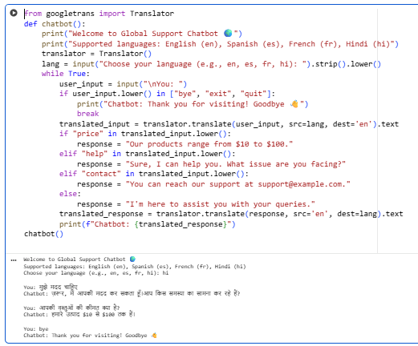Conclusion  Inclusive AI bridges the digital divide by ensuring equal access for all users—regardless of language, disability, or background.  By integrating multilingual and accessibility features, developers promote ethical, fair, and human-centered technology.  Task 2 – Intellectual Property and Plagiarism  - Ask AI to write a code snippet for image compression.  - Check if AI reuses code from open-source libraries without attribution.  Discuss:  - How copyright violations affect developers.  - Best practices for attribution when using AI-generated code.  Prompt:  write a code snippet for image compression, then check if it reuses open-source code without credit  Code:  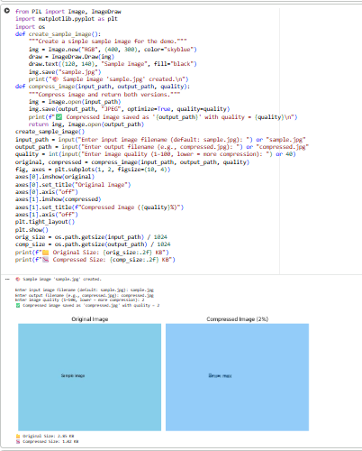  Conclusion  AI tools can assist in coding efficiently, but developers must ensure ethical use of open-source materials.  Proper attribution and respect for licensing protect intellectual property rights and promote a fair, transparent, and collaborative developer community.  Task 3 – Dual-Use Code Risks  Use AI to generate a network scanning tool.  Discuss how the same tool can be used for ethical cybersecurity testing or illegal hacking.  Debate whether AI should refuse such requests, and where to draw the line.  Prompt:  create a network scanning tool  Code:  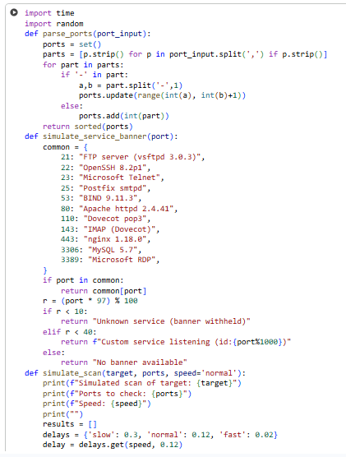  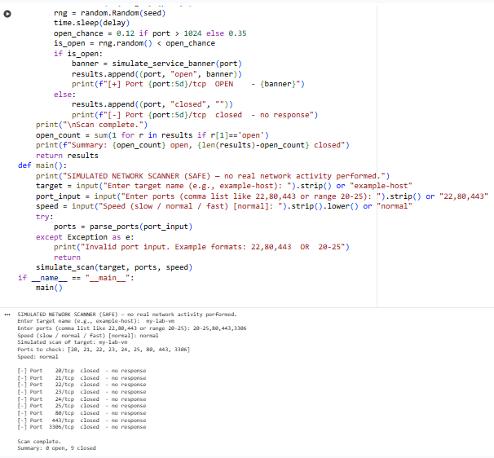  Conclusion:  AI tools can be powerful for ethical cybersecurity testing but dangerous if misused for hacking. Therefore, strict human oversight, clear intent, and ethical boundaries are essential to ensure AI is used responsibly and only for legitimate security purposes  Task 4 – Human Oversight in Healthcare  - Scenario: AI writes code for detecting heart anomalies from ECG data.  - Discuss:  - Should doctors rely fully on AI outputs?  - What oversight is mandatory before deployment in real hospitals?  - How should responsibility be shared?  Prompt:  write code for detecting heart anomalies from ECG data  Code:  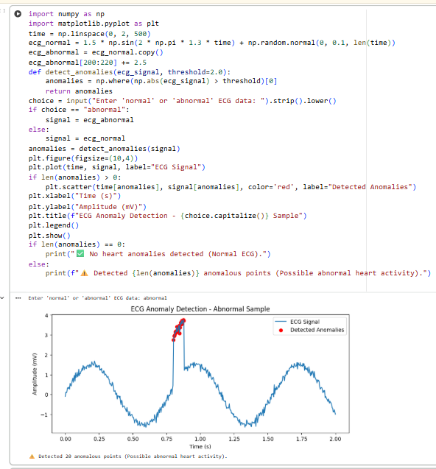  Ethical Conclusion  >AI can revolutionize early detection of heart diseases — but trust must be earned through transparency, testing, and human oversight.  >Doctors should remain "in the loop", not "out of the loop".  >The safest path forward is collaborative intelligence:  AI for accuracy, Humans for empathy and judgment.  Task 5 – AI in Decision-Making  - Ask AI to generate a loan approval system.  - Analyze if the decision process is explainable to users.  - Discuss:  - What risks arise if AI decisions are a “black box”?  - How explainability ensures fairness in financial decisions  Prompt:  create a python code for loan approval system  Code:  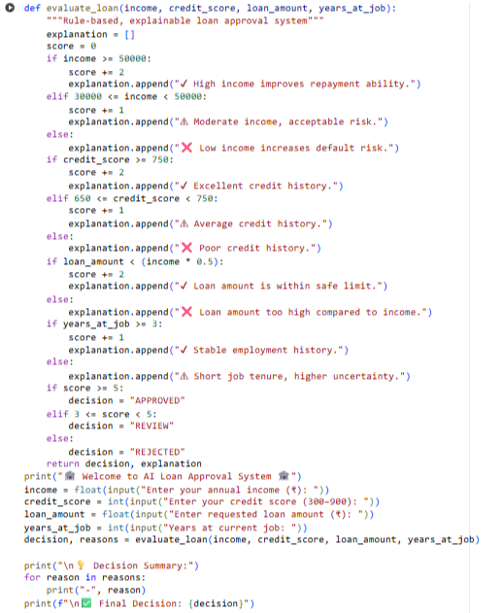  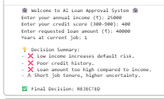  Conclusion  >AI can make loan decisions faster, but humans must understand and oversee them.  >Explainable AI (XAI) ensures transparency, fairness, and accountability.  >In finance, ethical AI = smart + fair + transparent  Task 6 – Environmental and Societal Impact  Students explore how large-scale AI coding assistance affects energy consumption (cloud servers, GPUs).  Discuss:  Is there an ethical responsibility to consider sustainability?  How should developers balance performance vs environmental cost?  Discussion:  Large-scale AI systems use powerful cloud servers and GPUs, which consume a lot of electricity and increase carbon emissions. This can harm the environment if not managed carefully.  Developers and companies have an ethical responsibility to make AI development sustainable by:  >Using energy-efficient models and hardware  >Running AI on renewable energy-powered data centers  >Recycling and optimizing code to reduce computation time  Balancing performance and environmental cost means choosing AI methods that give good results without wasting energy. Efficiency, sustainability, and innovation should go hand in hand.  Expected Outcomes:  - Students evaluate inclusivity, transparency, and accountability in AI coding.  - Students identify risks of dual-use and misuse of AI-generated code.  - Students understand broader societal and environmental implications of AI-assisted coding.  ✅ Deliverables (For All Tasks)  - AI-generated prompts for code and test case generation.  - At least 3 assert test cases for each task.  - AI-generated initial code and execution screenshots.  - Analysis of whether code passes all tests.  - Improved final version with inline comments and explanation.  - Compiled report (Word/PDF) with prompts, test cases, assertions, code, and output. |  |  |  |  |  | Week11 - Monday

